Crop Recommendation and Plant Leaf Disease Prediction Using CNN

Prof. Deepali M. Gohil

Department of Computer Engineering

D. Y. Patil College of Engineering,Akurdi., Maharashtra, India

Email- dmgohil@dypcoeakurdi.ac.in

Sakshi Pandharinath Dherange

Department of Computer Engineering

D. Y. Patil College of Engineering, Akurdi., Maharashtra, India

Email- sakshidherange153@gmail.com

Vrushali Sandip Datir

Department of Computer Engineering

D. Y. Patil College of Engineering, Akurdi., Maharashtra, India

Email- [vrushalidatir06@gmail.com](mailto:vrushalidatir06@gmail.com)

Vrushali Mahendrasing Patil

Department of Computer Engineering

D. Y. Patil College of Engineering, Akurdi.,

Maharashtra, India

Email- [vrushalipatil0605@gmail.com](mailto:vrushalipatil0605@gmail.com)

Shital Sandip Mehetre

Department of Computer Engineering

D. Y. Patil College of Engineering, Akurdi.,

Maharashtra, India

Email- [mehetreshital12@gmail.com](mailto:mehetreshital12@gmail.com)

## *Abstract -*In modern agriculture, accurate crop yield prediction and timely detection of plant diseases are crucial for ensuring food security and optimizing agricultural practices. This paper presents a novel approach, titled "Crop Recommendation and Plant Leaf Disease Prediction using Convolutional Neural Networks," aimed at addressing these challenges. The proposed system integrates advanced machine learning techniques, specifically Convolutional Neural Networks (CNNs), to automatically detect plant diseases from leaf images and recommend suitable crops based on various environmental factors. The system utilizes a diverse dataset of plant images, historical data on crop yields, weather patterns, soil conditions, and pesticide usage to develop a holistic solution for agricultural risk management and forecasting. We describe the step-by-step process of data collection, preprocessing, CNN model architecture design, training, crop recommendation system development, integration, user interface development, deployment, and maintenance. Experimental results demonstrate the effectiveness of the proposed approach in accurately predicting plant diseases and providing actionable recommendations for crop selection. The system holds significant promise in empowering farmers with valuable insights for efficient crop management, disease prevention, and maximizing agricultural yield.

## *Keywords -* Crop recommendation, Plant leaf disease prediction, Convolutional Neural Networks, Agriculture, Machine learning.

1. INTRODUCTION

The contemporary agricultural landscape stands at the intersection of tradition and innovation, where the imperative to enhance crop cultivation efficiency and disease-management strategies is paramount. With a burgeoning global population and diminishing agricultural land, optimizing crop yield while minimizing resource utilization and environmental impact is increasingly imperative. In today's agricultural landscape, the imperative to optimize crop cultivation efficiency and mitigate the risks posed by plant diseases has never been more pressing. This paper introduces the "Crop Recommendation and Plant Leaf Disease Prediction" project, aimed at addressing these challenges through data-driven solutions. The project comprises two core components: crop recommendation and plant leaf disease prediction, which leverage historical data, soil analysis, weather information, and advanced machine learning techniques to provide farmers with actionable insights tailored to their specific agricultural contexts.

The crop recommendation component utilizes a comprehensive dataset encompassing crop performance metrics, soil composition analyses, and local weather patterns to generate personalized recommendations for optimal crop selection. By analyzing past trends and environmental parameters, this component empowers farmers to make informed decisions that maximize yield and profitability while minimizing resource inputs. In parallel, the plant leaf disease prediction component employs convolutional neural networks (CNNs) for image recognition and predictive modeling, enabling the early detection and forecasting of potential disease outbreaks. Through the identification of subtle patterns indicative of disease onset, farmers can implement timely interventions to mitigate crop losses and ensure the sustainability of agricultural productivity. Together, these components represent a significant step towards harnessing the power of technology to revolutionize traditional farming practices and foster resilient food production systems.

1. LITERATURE SURVEY

**A Systematic Literature Review on Plant Disease Detection: Motivations, Classification Techniques, Datasets, Challenges, and Future Trends**

The systematic literature review investigates plant disease detection methods using AI and ML techniques. It emphasizes the importance of addressing challenges such as limited inspection capabilities and the need for efficient detection methods. The review examines 176 papers from major databases, focusing on vision-based approaches across various crops. It notes the effectiveness of SVMs and LR classifiers but highlights challenges in disease localization. The study identifies emerging trends like Cognitive CNNs and transfer learning. It mentions the absence of standardized performance metrics and highlights the availability of datasets, albeit with limitations in size and practicality. Finally, it underscores the necessity for developing models suitable for diverse crops, capable of running on small devices, and handling large datasets for robust disease detection systems [1].

**Crop Prediction Based on Characteristics of the Agricultural Environment Using Various Feature Selection Techniques and Classifiers**

The abstract discusses the importance of crop prediction in agriculture, highlighting the influence of soil and environmental conditions. It notes the shift from traditional farmer-based methods to machine learning techniques for prediction. Efficient feature selection methods are crucial for preprocessing raw data and improving model accuracy. The abstract emphasizes the significance of including only relevant features in the model to avoid complexity and maintain accuracy. Additionally, it suggests that ensemble techniques outperform existing classification methods in terms of prediction accuracy [4].

**Fast Plant Leaf Recognition Using Improved Multiscale Triangle Representation and KNN for Optimization**

The abstract discusses the importance of effective leaf-feature extraction methods for improving plant leaf recognition rates due to the complexity and similarity of plant leaves. Five multiscale triangle representations are studied, including three new representations: gray average, gray standard deviation, and side length integral. These representations are used to extract curvature, texture, and shape area features for a multiscale leaf-feature description. Additionally, a new adaptive KNN optimization method is proposed to enhance the retrieval rate of leaf datasets. Experimental results demonstrate that the proposed method achieves higher accuracy compared to state-of-the-art methods on the Swedish and Flavia plant leaf datasets, with respective accuracies of 99.35% and 99.43% and a Mean Average Precision (MAP) value of 84.76%. The method also shows comparable results on MPEG-7, kimia99, and kimia216 datasets. When combined with KNN optimization, the retrieval rate is significantly improved, particularly with a notable increase in MAP on the Flavia dataset to 94.48% [5].

**Chaotic Jaya Optimization Algorithm With Computer VisionBased Soil Type Classification for Smart Farming**

The abstract introduces a novel approach, the Chaotic Jaya Optimization Algorithm with Computer Vision-based Soil Type Classification (CJOCV-STC), designed for smart farming applications. It highlights the importance of smart farming in increasing agricultural yield through precise decision-making processes. The proposed CJOCV-STC method leverages computer vision (CV) and metaheuristic algorithms to automate soil classification, a critical parameter for crop selection. Specifically, it employs the SqueezeNet model for feature extraction and utilizes the Chaotic Jaya Optimization (CJO) algorithm for hyperparameter tuning. Additionally, the Elman neural network (ENN) technique is applied for soil type classification, with parameter adjustment facilitated by the chicken swarm algorithm (CSA). Experimental results on the Kaggle dataset demonstrate the superior performance of the CJOCV-STC algorithm, achieving an accuracy of 98.47% compared to other recent approaches [2].

**Machine learning based Pedantic Analysis of Predictive Algorithms in Crop Yield Management**

The abstract introduces the application of predictive analytics, particularly machine learning, in crop yield management. It highlights the potential of these technologies, combined with the Internet of Things (IoT), to address challenges in crop yield and enhance profitability. The paper conducts a comparative evaluation of various prediction algorithms, including support vector machines (SVM), recurrent neural networks (RNN), K nearest neighbor regression (KNN-R), Naïve Bayes, BayesNet, and support vector regression (SVR). Performance metrics such as error rates and accuracy levels are used to assess the algorithms' effectiveness in crop yield prediction. BayesNet achieves the highest accuracy at 97.53%, while RNN demonstrates the lowest percentage error rates, outperforming other algorithms in harvest prediction [3].

# PROBLEM STATEMENT

The agricultural sector faces several challenges, including suboptimal crop selection and the prevalence of plant diseases, which significantly impact crop yield and farmer livelihoods. Traditional farming practices often rely on subjective decision-making processes and limited access to timely information, leading to inefficient resource allocation and increased susceptibility to crop failures. Furthermore, the early detection and management of plant diseases remain formidable tasks, with manual inspection methods often proving inadequate for timely intervention.

To address these challenges, there is a pressing need for innovative solutions that leverage advancements in technology, particularly in the realms of data analytics and machine learning. Specifically, the integration of convolutional neural networks (CNNs) presents an opportunity to revolutionize crop recommendation systems and plant disease prediction methodologies. By harnessing the power of CNNs for image recognition and predictive modeling, it becomes feasible to analyze vast datasets encompassing soil characteristics, weather patterns, historical crop performance, and plant images to provide farmers with actionable insights tailored to their specific agricultural contexts.

Therefore, the problem at hand involves developing and implementing a robust framework for crop recommendation and plant leaf disease prediction using CNNs. This framework must address the complexities inherent in agricultural decision-making, including the dynamic nature of environmental factors, the diversity of crop varieties, and the rapid evolution of plant diseases. By effectively leveraging CNN-based approaches, the goal is to empower farmers with data-driven recommendations for optimal crop selection and early detection of plant diseases, thereby enhancing agricultural productivity, sustainability, and resilience in the face of evolving challenges.

1. GOALS AND OBJECTIVES
   * Disease Management Enhancement: The primary objective is to enhance disease control in agriculture by providing accurate plant disease diagnosis and treatment recommendations, thereby minimizing crop losses and promoting sustainable farming practices.
   * Educational Empowerment: Another goal is to empower users with comprehensive knowledge about crop management and plant diseases through an accessible learning platform. By educating farmers and agricultural stakeholders, the aim is to foster informed decision-making and proactive disease management strategies.
   * Data Security and Trust: Ensuring the security and privacy of user data is paramount to establish trust in the system. By implementing robust data security measures, the goal is to safeguard user information and cultivate confidence in the reliability and integrity of the platform.
   * Informed Decision-Making: The overarching objective is to assist users in making informed decisions about crop selection based on soil and climate conditions. By providing tailored recommendations, the goal is to optimize crop yield and resource utilization while mitigating risks associated with environmental factors and disease prevalence.

* Objectives:
  + Crop Recommendation System: Develop a reliable crop recommendation system that takes into account various agricultural factors such as soil type, climate, and historical performance data. The objective is to provide farmers with personalized recommendations tailored to their specific farming conditions and goals.
  + Disease Detection Implementation: Implement a trustworthy disease detection system capable of accurately identifying plant diseases based on image recognition and machine learning algorithms. The objective is to enable early detection of diseases, allowing for timely intervention and effective disease management practices.
  + User-Friendly Interfaces: Provide intuitive and user-friendly interfaces, including mobile applications, to facilitate convenient interaction with the platform. The objective is to enhance user experience and accessibility, ensuring that farmers and stakeholders can easily access and utilize the system to make informed decisions.
  + Continuous Improvement: Commit to regular updates and enhancements of the system to ensure ongoing accuracy and reliability in providing recommendations and disease detection. The objective is to adapt to changing agricultural dynamics and technological advancements, continuously improving the platform's effectiveness and usability over time.

## METHODOLOGIES OF PROBLEM SOLVING AND EFFICIENCY ISSUES

* Methodologies of Problem solving
* Iterative Development: Adopting an iterative approach allows for breaking down the project into manageable tasks or features, implementing them incrementally, and refining each component iteratively. This method enables continuous improvement by incorporating feedback and enhancements along the way. For our project, iterative development ensures the gradual refinement of crop recommendation algorithms and disease prediction models based on real-world data and user feedback.
* Agile Methodology: Embracing agile practices such as Scrum or Kanban fosters collaboration, adaptability, and continuous improvement throughout the development process. Regular sprint planning, daily stand-ups, and retrospectives ensure alignment with project goals and address any challenges promptly. In the context of crop recommendation and disease prediction, agile methodologies facilitate efficient coordination among team members, allowing for rapid iteration and response to evolving agricultural needs and technological advancements.
* Modular Design: Designing the crop recommendation and disease prediction system using a modular architecture enhances scalability, maintainability, and flexibility. By encapsulating different components and functionalities into reusable modules or services, the system becomes easier to extend and integrate with new features and enhancements. Modular design facilitates the seamless integration of CNN-based algorithms for image recognition and predictive modeling, ensuring robustness and adaptability in addressing diverse agricultural scenarios.
* Continuous Integration and Deployment (CI/CD): Implementing CI/CD pipelines automates the build, test, and deployment processes, reducing manual errors and accelerating the release cycle. Continuous integration ensures that code changes are continuously integrated into a shared repository, while automated tests validate the functionality and performance of the system. Continuous deployment enables seamless deployment of updates to production environments, ensuring that users have access to the latest features and improvements. In the context of crop recommendation and disease prediction, CI/CD pipelines streamline the development and deployment process, enabling rapid iteration and delivery of enhancements to farmers and agricultural stakeholders.

1. ALGORITHM OVERVIEW

Convolutional Neural Networks (CNNs) are a specialized class of deep neural networks primarily utilized for processing and analyzing visual data, such as images and videos. They employ a hierarchical architecture consisting of layers designed to extract and learn features from raw input data. Key components include convolutional layers, Rectified Linear Unit (ReLU) layers, pooling layers, and fully connected layers. Through this structured arrangement, CNNs are able to effectively capture spatial hierarchies and patterns within the input data.

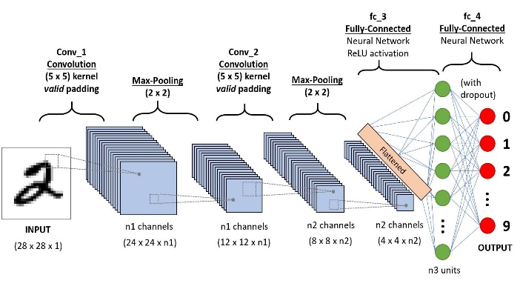

Fig.1. A simple Convolutional Neural Network Architecture

One distinguishing feature of CNNs is their connectivity pattern, which mimics the organization of neurons in the visual cortex of animals. This connectivity allows each neuron to only process information from a small region of the preceding layer, resembling receptive fields. This design facilitates the extraction of local features and enables the network to learn complex representations by combining simpler ones. Additionally, CNNs employ mathematical operations called convolutions, which enhance their ability to detect patterns within the data through specialized filters.

CNNs offer several advantages over traditional image classification algorithms. They require minimal pre-processing of input data since they learn feature representations directly from raw data, eliminating the need for manual feature engineering. Furthermore, CNNs can adapt to various tasks without prior human intervention, making them highly versatile and applicable in a wide range of domains including image recognition, object detection, and natural language processing. Overall, the hierarchical structure, specialized connectivity, and adaptability of CNNs make them powerful tools for processing graphical information and solving complex pattern recognition tasks.

* PROPOSED ALGORITHM

Image classification has created a boom in the era when it is combined with the deep learning models. The various plant diseases can be analyzed with the deep convolutional neural network. A large dataset has to be fed during the training so that it could be able to predict the disease with utmost accuracy.

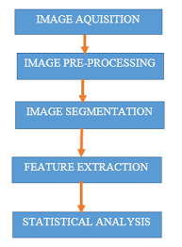

Fig.2. Basic steps in Image processing

* Image Acquisition: To find the disease associated with plant, we take a picture of the leaf of the plant and is then uploaded into the system.
* Image Preprocessing: The input image data is improved to remove noise or distortions before moving on to the next phase.
* Image Segmentation: Image segmentation is the process through which we partition the image into multiple segments that can be defined as super-pixels. It helps us to analyze the image easier.
* Feature Extraction: It extracts the shape information contained in an image to identify the pattern it is classified into. Feature extraction is another form of dimensionality reduction.
* Classification: This phase is responsible for categorizing the pixel information in a digital image.

Since the rapid detection of diseases can help in the increase of production rate of plants, the accurate and fast prediction of disease with a solution can have a good impact on the agricultural industry.

Data Collection: The data collection process involves gathering a diverse dataset comprising plant images and historical agricultural data. Plant images are sourced from various channels, including online repositories, field surveys, and collaborations with agricultural institutions. Care is taken to ensure that the images cover a wide range of plant species and include samples of both healthy plants and plants affected by various diseases. Additionally, historical agricultural data, such as crop yields, weather patterns, soil conditions, and pesticide usage, are obtained from reliable sources such as government agencies, research institutions, and agricultural databases.

Data Preprocessing: Upon acquiring the dataset, image preprocessing techniques are applied to enhance the quality and relevance of the collected images. This involves standardizing image resolution, normalizing pixel values, and employing augmentation techniques such as rotation, flipping, and cropping to increase dataset diversity. Furthermore, historical agricultural data undergo cleaning and preprocessing to ensure consistency and compatibility with the recommendation system. This may involve tasks like data normalization, outlier detection, and missing value imputation to prepare the data for subsequent analysis.

CNN Model Architecture Design: A Convolutional Neural Network (CNN) architecture is meticulously designed for plant disease prediction from leaf images. The architecture typically comprises convolutional layers, pooling layers, and fully connected layers, tailored to extract meaningful features from the input images. Consideration is given to the potential use of transfer learning and pre-trained models to leverage existing knowledge and enhance model performance, particularly in scenarios where labeled data is limited. Hyperparameters such as learning rate, batch size, and optimizer choice are carefully tuned to optimize the model's training process.

Training the CNN Model: The dataset is partitioned into training, validation, and testing sets to facilitate the training and evaluation of the CNN model. The CNN model is then trained on the training set using backpropagation and gradient descent optimization techniques. Throughout the training process, model performance is monitored on the validation set to prevent overfitting and fine-tune hyperparameters as necessary. Subsequently, the trained model's performance is evaluated on the testing set using evaluation metrics such as accuracy, precision, recall, and F1-score to assess its effectiveness in disease prediction.

Crop Recommendation System Development: Algorithms for crop recommendation are developed based on historical agricultural data and environmental factors. Various techniques such as decision trees, random forests, or collaborative filtering may be employed to suggest suitable crops for a given region or field. The recommendation system takes into account factors such as soil type, climate, historical crop yields, and pest incidence rates to provide personalized recommendations tailored to the specific needs and conditions of the user.

Integration of CNN Model and Recommendation System: The trained CNN model for disease prediction and the crop recommendation system are seamlessly integrated into a unified platform or application. This integration is facilitated by the use of APIs or middleware to enable smooth communication between the two components, allowing for seamless interaction and data exchange. By integrating both components, users can benefit from a comprehensive solution that offers both disease diagnosis and crop selection functionalities in a single interface.

User Interface Development: A user-friendly interface is designed and implemented to enable farmers or agricultural professionals to interact with the system effortlessly. The interface allows users to upload images of plant leaves, input environmental data, and receive recommendations for disease diagnosis and crop selection. Additional features such as real-time feedback and visualization of results may be incorporated to enhance the user experience and facilitate informed decision-making.

Deployment: The integrated system is deployed as a web or mobile application, making it accessible to users across different devices and platforms. Deployment considerations include scalability, reliability, and security to ensure smooth operation in production environments. By deploying the system, users can leverage its capabilities to enhance crop management practices and mitigate the impact of plant diseases on agricultural productivity.

Monitoring and Maintenance: Strategies for monitoring system performance and gathering user feedback are implemented to ensure continuous improvement and user satisfaction. The system is periodically updated based on new data, insights, and user requirements to maintain relevance and effectiveness. By monitoring and maintaining the system, its performance can be optimized over time, ensuring that it continues to meet the evolving needs of its users and delivers value in agricultural operations.

# RESULTS

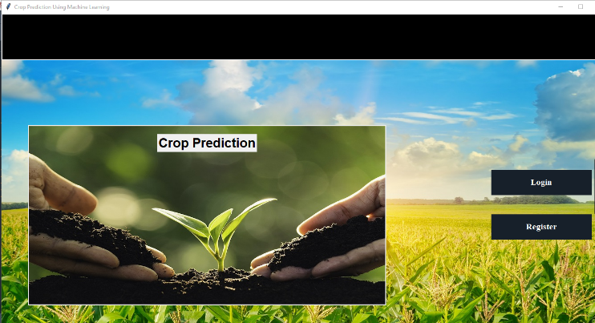

Fig.3. Login and Register

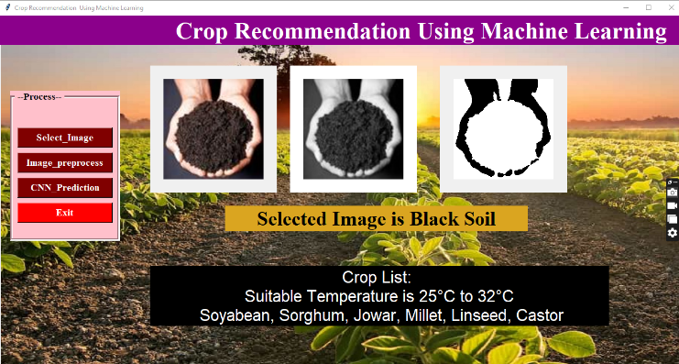

Fig.4. Crop Recommendation

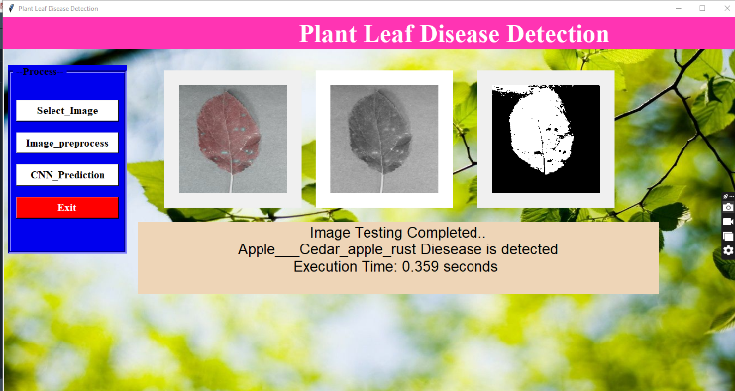

Fig.5. Leaf Disease Prediction

# CONCLUSION

In this project, embodies the promise of data-driven innovation in agriculture. Through the strategic use of Convolutional Neural Networks (CNNs), the project empowers farmers with personalized crop recommendations and early disease detection, contributing to improved resource management and crop health. This initiative not only addresses immediate agricultural challenges but also paves the way for sustainable and efficient practices. In a world facing evolving environmental conditions and a growing need for food security, this project serves as a beacon of hope, highlighting the pivotal role of technology in transforming agriculture. It underscores the potential for data-driven decision-making to enhance crop yields, protect food supplies, and support the livelihoods of farmers, ultimately ensuring a more secure and sustainable future.

In conclusion, our proposed system represents a significant advancement in leveraging technology to address agricultural challenges. By empowering farmers with actionable insights, we contribute to more efficient crop management, disease prevention, and yield optimization. Moving forward, further development and refinement of the system will ensure its widespread adoption and transformative impact across diverse agricultural landscapes, fostering a more sustainable and productive future for agriculture.

# REFERENCES

*[1] Wasswa Shafik, Ali Tufail, Abdallah Namoun, Liyanage Chandratilak De Silva, And Rosyzie Anna Awg Haji Mohd Apong, “A Systematic Literature Review On Plant Disease Detection: Motivations, Classification Techniques, Datasets, Challenges, And Future Trends,’’.*

*[2] Hussain Alshahrani, Hend Khalid Alkahtani , Khalid Mahmood, Mofadal Alymani, Gouse Pasha Mohammed, Amgad Atta Abdelmageed, Sitelbanat Abdelbagi, And Suhanda Drar, “Chaotic Jaya Optimization Algorithm With Computer Vision-Based Soil Type Classification For Smart Farming”*

*[3]M Chandraprabha, Rajesh Kumar Dhanaraj, “Machine Learning Based Pedantic Analysis Of Predictive Algorithms In Crop Yield Management”.*

*[4] S. P. Raja, Barbara Sawicka, Zoran Stamenkovic, And G. Mariammal, “Crop Prediction Based On Characteristics Of The Agricultural Environment Using Various Feature Selection Techniques And Classifiers”.*

*[5] Jianyu Su, Meihua Wang, Zhenxin Wu, And Qingliang Chen, “Fast Plant Leaf Recognition Using Improved Multiscale Triangle Representation And Knn For Optimization”.*